ASSIGNment 1: Image analysis
BY: Patrick Obispo

INTRODUCTION
The theme that I have chosen is Gender. In this essay I will be analyzing three images that contain the three sexes men, women and the homosexuals. In the world of advertisements stereotyping exists especially in men and women. Men are seen to be the dominant ones while the women are seen soft and harmless. Homosexuality is rare in advertisements and it often creates controversies with some of the members of the public. But in this generation stereotyping is long gone and acceptance exists within the society.
  - THEME: Gender

IMAGE 1: WOMEN
Analysis:
This advertisement is breaking the stereotypical gender role of women. Back then women were advertised as weak or “simple”. But in this image we see the women being powerful and dominant while the men are seen helpless and weak. Therefore there is a role reversal in this advertisement. Although the product is not seen the message of this ad is powerful.
In this advertisement we see the women aggressively handling the men and we see a woman strongly holding a whip that suggests dominance. Although the staging of the advertisement is very powerful the faces of the women remains soft and beautiful which suggests that femininity is still present. They are styled chic and fashionable but the dark colour of their dress proposes maleficent. The women are both feminine and bad. The fact that they are standing and looking down on the men makes them dominant.
On the other hand masculinity is strip off of the men. The removal of their shirt is used as a simile. While the shirt is being taken off it is like their masculinity being strip off. They are kneeling down and naked. This suggests weakness despite of their built. It is noticeable the man in the middle is sweating. This is a sign of nervousness. The faces of the men are not seen. Therefore we cannot see the emotion of the two men as they are being overpowered by the women. They are also wearing black but it does not suggest any power or dominance. It promotes death or weakness.
This advertisement can be interpreted as being violent, malicious or sexist while on the other hand some people may see it as a change of the role of women in the society. From being the excluded they are now standing up for themselves.

Target audience/Mode of Address
It is obvious who the target audience of this Dolce and Gabbana advertisement. Despite of the absence of the product it is clear that this is aimed at women who are aged between 25 – 50 years of age. They are not aimed at men. The styling of the women can also suggest who the target audience are. They are styled chic therefore they are aiming for women that are passionate about fashion.

Technical Codes
There are many technical codes within this advertisement. The camera angle is very close to them. This is a way to emphasise the strong yet feminine faces of the women. This is also a way to see the dominance they are creating. The setting of this ad is very dark and eerie. It looks like they are in an isolation room of a mental hospital. It creates a terrifying image. The colours used are mostly black and silver. The colour black and silver creates a powerful image and suggests danger. It also adds the dominatrix atmosphere. It also makes the ad sophisticated. The lighting in the advertisement is gloomy which adds on the unsettling atmosphere.

Symbolic Codes
The symbolic codes include the gladiator bracelet and the whip. These two things were seen in the Rome-era where gladiators were known. The bracelet worn by the woman is like the one the gladiators use to wear for battle. It suggests power and a strong personality. The whip, on the other hand, is often used by masters back in the Rome-era. This suggests control and dominance. The colour black can also be a symbolic code as it emphasise danger or death.

Ideological functioning of the image
This advertisement promotes the idea of feminism. They are trying to promote that women in this generation are equal to the men. It is trying to promote the change of role of women in the society. It is abolishing the discrimination that happens between these two genders. They are trying to eliminate the idea of the women being inferior to men. They are emphasising that there should be equal rights shared between men and women. This ad is telling us the idea of women being strong and they are able to do things that men can.

Terminology of semiotics
Signifier: The three women and the two men.
Signified: The three women represents the ability to be powerful and to be strong.
The two men tells us that the role of women in the society has indeed changed.
Denotation: Black coloured dress of the women and the clothing of the men.
Connotation: Black represents darkness and evil. It can also represent danger or death.

IMAGE 2: MEN
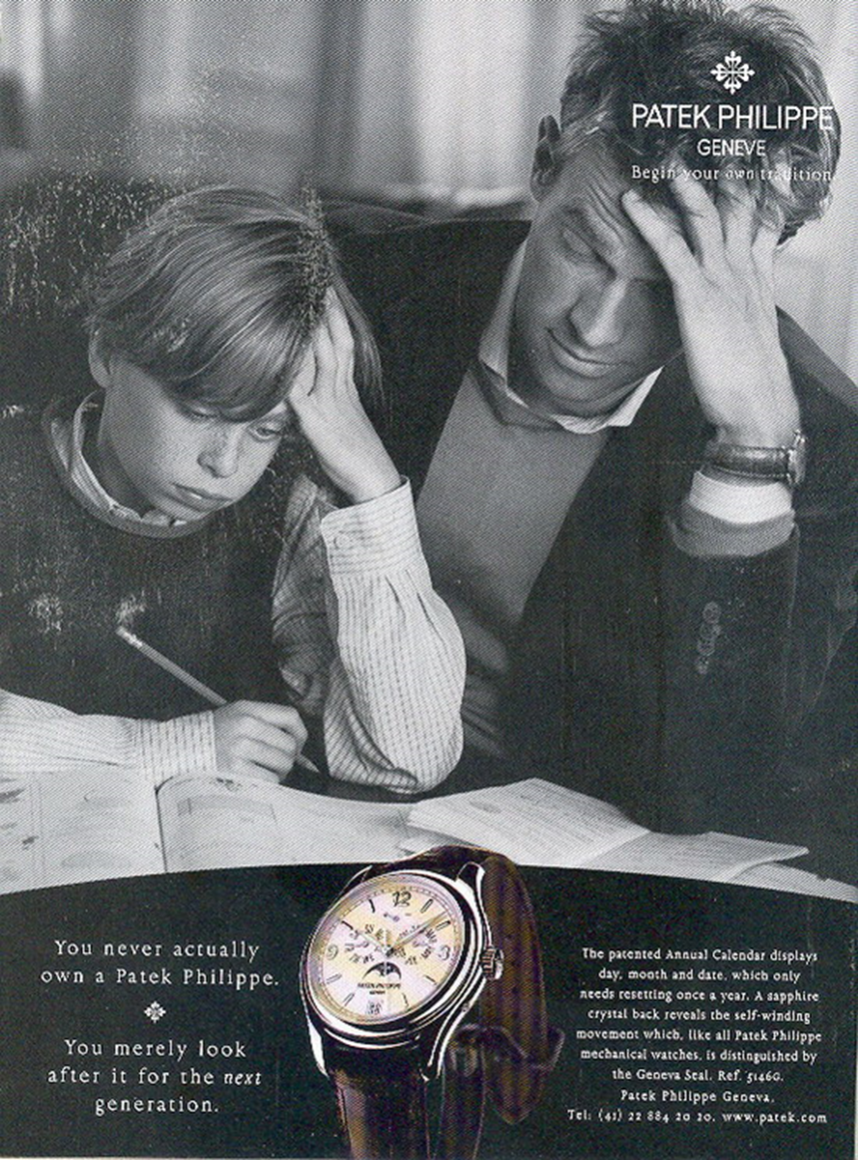

Analysis
This advertisement is also departing from the stereotypical gender role men. Back then men were depicted to be masculine and dominant. They also think that they are superior. Men were not expected to do housework or any doings of women. The ideas of being insensitive are not seen in this advertisement.
In the advertisement we can see a father and son doing homework. The father is helping out the son do his work but it looks like both are struggling. This kind of relationship was not seen in advertisements back then. Usually women were the ones to help their child. This indicates that the role of men in society have changed overtime. This advertisement is suggesting that men can be sensitive and caring.
The act of struggling from the man is interpreted in two ways. It can be seen as a discrimination against men. This advertisement is telling us that men are not capable of doing simple things. But it can also be interpreted as humour. The advertisement creates a funny side to it. The look in each other’s faces creates this innocent feeling and cuteness.
The slogan of this ad conveys a message. The “You never actually own a Patek Philippe, You merely look after it for the next generation” (Patek Philippe 1996) tells us that the watch is passed eternally. As it does it becomes very important to the present holder. The product is clearly seen in this advertisement. The watch is highlighted by having it on the wrist of the man and a big picture of it.

Target audience/Mode of Address
The target audience for this advertisement is the fathers or ordinary men. It’s targeted to an age group between 20 – 50 years of age. The man in the picture is an average guy therefore it is marketed to men that have simple fashion. The watch itself looks average but very classy. This tells us that anyone can buy the product if they like something classy.

Technical Codes
The colour of the ad is in black and white which indicates the product is sophisticated. The only thing that is in colour is the watch. This is to emphasise how it looks like. The setting is in a house which makes the ad relaxing. The camera angle is near them. By doing this we can see the faces of the two and suggest intimacy. We can also see their hands on their forehead. We can see the struggle they are in. This adds the innocent feeling and the cuteness in the ad.

Symbolic Codes
The pouting lip of the child is seen as a symbolic code. This is because the pouting lip can tell different stories. In this case it tells us the struggle he is in. This is also a normal act from a normal child. Therefore it makes the ad genuine. The watch is also a symbolic code. The watch has a very tradition design. This perfectly represents what the ad is going for, classy yet simple.

Ideological functioning of the image
This advertisement promotes the idea of family love and the role of men. It is obvious that there is family love within the ad. There is a father and son relationship. The ad suggests that the father loves his son. Even though it’s not shown we can still feel it. The son loves the father because the son trusted the father to help him. The father loves the son because he helped him. In conclusion it tells us that the role of men in society have changed over time. They went from being the masculine and the dominant to the caring and selfless men.
Terminology of Semiotics
Signifier: The man and the boy.
Signified: The man suggests the role of men in society have changed.
The boy represents the love the father is giving.
Denotation: Pouty lip and the hands on their heads.
Connotation: It represent struggle.

IMAGE 3: HOMOSEXUAL
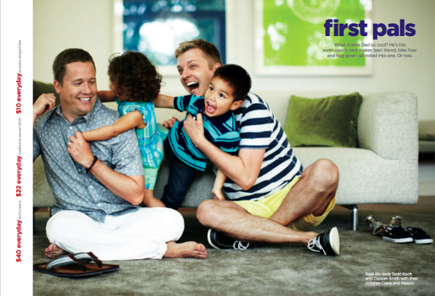

Analysis
Gay advertisements often create controversies but in this era acceptance exists. In this advertisement we see two happy men with two kids. At first we didn’t know what relation they have but we realize that they are a family. As stated in the article of (Krumboltz, 2012) the ad features real-life same-sex couple, Todd Koch and Cooper Smith, with their two children. Often in family ads they consist of a man and a woman as parents but in this case it’s not. This ad is promoting a modern world where anybody can have a family and become parents.
In this ad we see a family who are very happy with each other. The setting of the ad is at home. The staging of the ad creates a soft imagery of family. The product is clearly shown in the ad which is the clothes. The company is saying that there clothes are wearable to anyone. The colours in the ad are very simple yet refreshing to the eye. This ad also has that genuine feeling. There is no fakery within the ad i.e. it doesn’t feel like it is staged. There is only family love present.
The ad is making a strong statement to the public. The message the company, which is J.C Penney, is trying to convey is that the gay community are allowed to have a family if they want to. This ad shows that same-sex parents can be loving like normal parents. The ad is universal meaning anybody can relate to it whether you’re straight, gay or lesbian.

Target audience/Mode of Address
The target audience for this ad is for all genders especially the homosexuals. The ad is focusing in family therefore it can be relatable to anyone. The company focuses on the gay community because they want them to feel included in the society. The ad also targets heterosexuals with a family even though it features a gay family. The ad shows values of a loving family. It is also targeted to those who has simple fashion yet wants good quality of clothes.

Technical Codes
The camera angle is close to them. By doing this we can see the emotions of the main subject i.e. the family. They look very happy with each other. The setting of the ad is in the living room. This creates a relax atmosphere and it emphasises the feeling of at home. The lighting and the colours of the ad is very bright. This adds to the fun factor seen in the ad. This also can make the public smile. The way the fathers are hugging their children let us know that they love them. The children in return show their love by smiling.

Symbolic Codes
The colours in the ad are a symbolic code. The ad is full of colours which can be interpreted in different ways. Back then the meaning of “gay” is gleeful or joyful. Therefore the word is incorporated with the colours in the background and the family. The colours in this ad is “gay” because it looks joyful. The family in this ad is “gay” meaning they are happy and they look like they love each other. So the word “gay” can also mean happiness of a person or people and not only homosexuality.

Ideological functioning of the image
The ideology of this image is equality and acceptance. The ad is showing the public that homosexuals can love and want to be accepted in the society. The idea of equality is promoted in this ad. The image is telling the public that homosexuals have the right to do anything they want whether it be having a family or getting married. They want to have equal rights that heterosexuals have. The clothing company J.C Penney is also trying to convey an idea of diversity. They are branding their company as gay friendly as well as society friendly. They are trying to say that their clothes do not discriminate and they are for everybody. This makes their clothes stand out.

Terminology of semiotics
Signifier: The two same-sex couple and their children.
Signified: Family and love.
Denotation: Background colours
Connotation: “Gay” meaning happy and cheerful.

