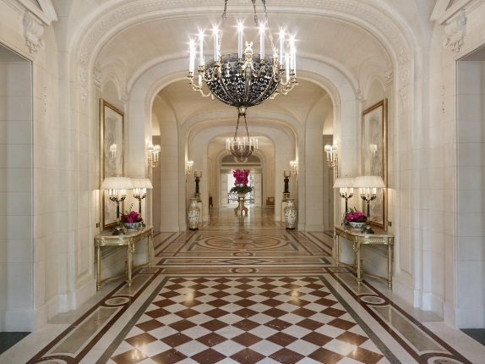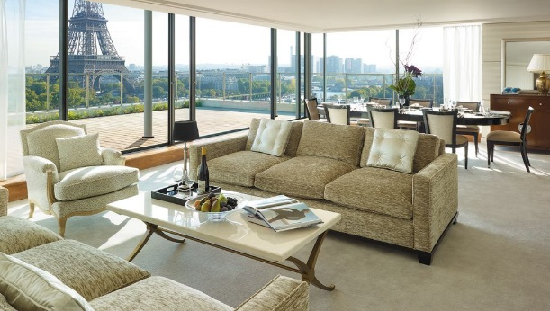
Shangri-La hotel Paris
Luxurious…Relaxing… Perfect…
Book now in the world’s best five-star hotel…
Best in customer satisfaction…
Many services and facilities including…
- Spa and Swimming pool
- Bar and Restaurant
- Luxurious Bedrooms and many more…
EXAMPLE PRICES (BEDROOMS):
- Eiffel Premier Room (King) - €1,200/night
- Superior Room (King) - €700/night
- Deluxe Room (King) - €800/night

Experience the best only in Shangri-La hotel Paris. Experience fine dining, great beverages and relaxing bedrooms and facilities!
SO WHAT ARE YOU WAITING FOR? BOOK NOW
FOR RESERVATIONS: | CALL:
Shangri-La hotel Paris | 0800 90 8153
J’amie Shangri-La hotel Paris!

