Sales 1st Qtr 2010
Category | January | February | March
PC Computers | €128,000 | €135,000 | €142,000
Laptops | €56,000 | €58,000 | €62,000
Printer | €25,000 | €28,000 | €35,000
Peripherals | €18,000 | €22,000 | €28,000
Totals
sales forecast

The projected income from other interests over the same period are listed below:

Interest | January | February | March
Installations | €30,000 | €25,000 | €22,000
Repairs | €12,000 | €10,000 | €9,000
Consultations | €8,000 | €9,000 | €9,500
Software | €5,000 | €8,000 | €17,000

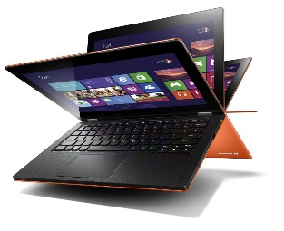
All computers are sold with Windows TM operating system pre-installed. This affects the profit margins on all sales of computers as the licenses for these operating systems are priced in US$.

